Benefits of banana peels and orange peels

[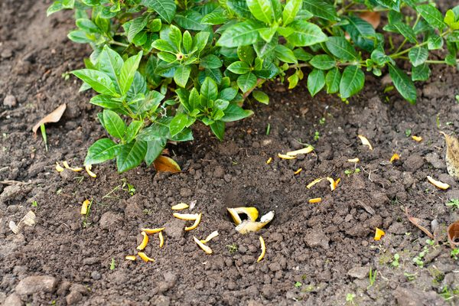](https://balconygardenweb-lhnfx0beomqvnhspx.netdna-ssl.com/wp-content/uploads/2016/06/Banana-Peels-Orange-Peels-in-the-Garden.jpg)

Before you toss another orange or banana peel into the trash, stop and think about the potential benefits you may be throwing away. Like other kitchen scraps, these peels can be added to the compost bin or used directly in the garden as a replacement for chemical fertilizers or insecticides.